For Press Release:
Janie L. McGhin NP-BC, CDE
(229) 474-4101
jlmcghin@att.net

Partners in Health Management has received Accreditation for Diabetes Self-Management Education/Training through the American Association of Diabetes Educators (AADE), according to clinic director Janie McGhin. AADE is a National Accredited Organization, certified by the Centers for Medicare and Medicaid Services. Partners in Health Management is a health care clinic specializing in Diabetes Education and Medical Nutrition Therapy.
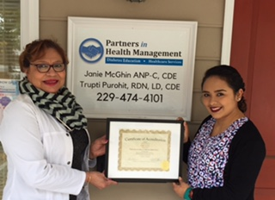 “AADE’s accreditation assures that an accredited program meets the National Standards for Diabetes Self-Management Education and Support,” according to the organization. “Programs who meet this criterion are considered high quality and have been shown to improve the health status of the individuals who embrace the education and help to modify sometimes unhealthy behaviors, or simply provide the education that the person with diabetes has not previously received.”
Diabetes education is a collaborative process through which people with or at risk for diabetes gain the knowledge and skills to modify behavior and successfully self-manage the disease and its related conditions. The program is comprehensive and taught by certified diabetes educators who have extensive training. Classes and other services are available in both English and Spanish.
Partners in Health Management also provides primary care services such as wellness physicals, treatment of minor injuries and illnesses, management of chronic diseases (hypertension, cholesterol diabetes), and men’s and women’s health services.
The clinic located at 202 West Gordon Street, is opened 9am-5pm Monday through Thursday and Friday morning by appointment.
“At Partners in Health Management we look forward to providing high quality healthcare to culturally diverse individuals from all walks of life, so they can hopefully live longer more productive lives,” McGhin said. “Call us and make your appointment today.”

